Adapted From 8 Interesting (And Insane) Male Rites of Passages From Around the World
by Brett & Kate McKay on February 21, 2010
http://www.artofmanliness.com/2010/02/21/male-rites-of-passage-from-around-the-world/

The Ancient Spartan Helot Killing
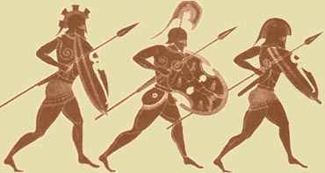
For ancient Spartans, becoming a soldier was the only way one could be recognized as a man. Military training began at age seven when boys would be taken from their families and placed in the Agoge system. For the next 10 years Spartan boys learned the skills necessary to become a trained killing machine.
When a Spartan youth turned 18, he completed his training. To graduate and be recognized as a man in his community, the boy had to undergo a cruel rite of passage called the krypteia. The young man would be sent to the countryside with only a knife and his wits. His object? To kill as many state-owned slaves, called helots, without being detected and return to his school in one piece. The young men would often hide during the day and make their attacks at night. In order to complete this rite of passage successfully, the young man had to call on all the training he received in the Agoge.
After successfully completing the krypteia, a Spartan man was expected to marry and continue killing for the state.

Satere-Mawe Bullet Ant Glove
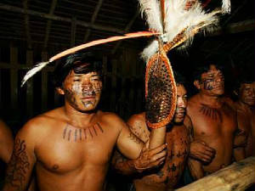
Deep in the heart of the Brazilian Amazon lives the Satere-Mawe tribe. To become a man in the Satere-Mawe, a boy must stick his hand in a glove woven with bullet ants and withstand their stings for over 10 minutes without making a noise.
According to the Schmidt Sting Index, the bullet ant has the most painful sting in the ant world. It’s described as “waves of throbbing, all consuming pain” that continues for over 24 hours. In fact, the locals call the ant, hormiga venticuatro because the pain from the sting lasts 24 hours.
Now if the sting from one bullet ant is that painful, imagine the pain you’d experience if you put on a glove made entirely of pissed-off bullet ants.
To make the glove, the tribesmen will knock out the bullet ants with a natural sedative. While the ants are docile, the elders proceed to make their torture device by weaving the ants into a glove made of leaves with the ants’ stingers facing inwards.
When the ants regain consciousness, the boys put on the gloves and face 10 minutes of pure, unadulterated hell. The copious amounts of venom the boy receives during the ordeal will temporarily paralyze his arm and leave him shaking uncontrollably for days.
This isn’t a one-time deal, either. A young boy may have to stick his hand in the bullet ant glove several more times before he’s considered a man. Each time he experiences the ordeal, the object is to remain as quiet as possible. It’s a test of manly endurance and stoicism that’s necessary to be effective warriors for the tribe.

Maasai Warrior Passage
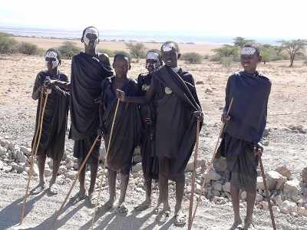
The Maasai of Kenya and Tanzania have a series of rites of passage that carry boys into manhood. Every 10 or 15 years a new warrior class will be initiated into the tribe. Boys between the ages of 10 and 20 are brought together from all across the country. Dozens of houses are built that will serve as the place of initiation. The night before the ceremony, the boys sleep outside in the forest. At dawn, they return to the little makeshift homestead for a day of singing and dancing. They drink a mixture of milk, cow’s blood, and alcohol and eat piles and piles of meat. After the festivities, boys who are of age (12-16) are ready to be circumcised.
The Emuratare is the most important ceremony in the life of a Maasai boy. Once circumcised, the tribe will consider him a man, warrior, and protector of his village. As the young man makes his way to where the elders will circumcise him, friends and family members will taunt the boy by saying things like “If you flinch, we will disown you.” The Maasai value bravery in their warriors and the circumcision is a boy’s first way to prove his courage even in the face of severe pain. It takes about 3 months for the circumcision to heal and during that time the young men wear black clothing and live in huts built by the women of the villiage. The Maasai boy is now warrior.
For the next 10 years the young men live together in an Emanyatta, or warriors camp. There they learn fighting, oratory, and animal husbandry. After 10 years, the young men take part in the Eunoto ceremony that marks the transition from warrior to senior warrior. After a Maasai has passed through the Eunoto, he can marry. The ceremony is basically several days of festivals, which ends with the initiate’s mother shaving his hair.

Mandan Hook Hanging
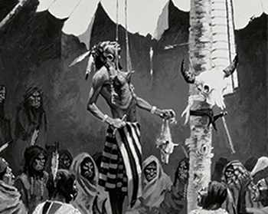
Native American tribes each had their own unique coming of age rituals for the men in the tribe. But few were as intense as that of the Mandans. Before his rite-of-passage, a Mandan boy fasted for 3 days to cleanse his body of impurities. Then, on the day of the ritual, elders of tribe would pierce the boy’s chest, shoulder, and back muscles with large wooden splints. Ropes, which extended from the roof of a hut, were then attached to the splints, and the young man was winched up into the air, his whole body weight suspended from the ropes. Despite the pain, the boy was not to cry out in pain. While hanging in the air, more splints were hammered through his arms and legs. Skulls of his dead grandfather and other ancestors were placed on the ends of the splints.
Eventually, the young man fainted from the loss of blood and the sheer pain of the torture. When the elders were sure he was unconscious, he was lowered down and the ropes were removed. Yet the splints were left in place. When the young man recovered consciousness, he offered his left pinky to the tribal elders to be sacrificed. He placed his finger on a block and had it swiftly chopped off. This was a gift to the gods and would enable the young man to become a powerful hunter. Finally, the young man ran inside a ring where his fellow villagers had gathered. As he ran, the villagers reached out and grabbed the still embedded splints, ripping them free. The splints weren’t allowed to be pulled out the way they had been hammered in, but had to be torn out in the opposite direction, causing the young man even greater pain and worse wounds. This concluded the day’s ceremony, and the boy was now a man.

